PAPER TITLE – WITH CAPITAL LETTERS, CENTER, BOLD, TIMES NEW ROMAN, SIZE 14,

First author¹, second author, …., … – Times New Roman, bold, 12
¹ Institute/University - Times New Roman, 10
² Another Institute/University - Times New Roman, 10
Remark: If all authors are from the same university it is not necessary to use numbering/superscript for each author’s name.
Corresponding author: Author, Institute, address, email – Times New Roman, 10, Italic

ABSTRACT
The abstract should contain short background, methods, results and conclusion of the research. (Times New Roman, 10). The abstract should not exceed 2000 characters (with spaces). Single-space line pitch.
Keywords: Up to five key words that summarize the contents of the paper (Times New Roman, 10)

INTRODUCTION

Paper should consist of introduction, methods, results and discussion, conclusions, references, and if available, acknowledgements. The manuscript should be formatted using 12 pts Times New Roman font, single spaced paragraph, with indentation of the first line at 1,25 cm.
Abbreviations should be kept to a minimum. Use of standard abbreviations is acceptable. Linguistic accuracy is the responsibility of the authors. Please note that each one of the paper should not exceed 15 pages at maximum including text, figures and tables. Papers should be written in English Language.
The Introduction should provide a clear statement of the problem, the relevant literature on the subject, and the proposed approach or solution.

METHODS and data (study area)

The size of the paper is 21 × 29.5 cm (A4) with margins: 2.5 cm from left, 1.5 cm from right and 2 cm from top and bottom.

Tables
You should number each table serially with Arabic numerals and put table headings above the table – Align Centre. If necessary use a smaller font size (11 pt or 10 pt but not smaller) to make tables fit the page size. Tables have to be in the relevant space in the text.

Table 1. Centered, in the document, Font Times New Roman, Size 12 pt

Table 1. Name
Setting | A4 size paper
Top | 2 cm
Bottom | 2 cm
Left | 2.5 cm
Right | 1.5 cm

Figures and images
Illustrations and figures should be numbered, incorporated in the document at the appropriate place. They should be accompanied by figure caption under the figure. All objects used in one figure should be grouped. Make sure the size of lettering within figures is big enough. The text should include references to all figures.

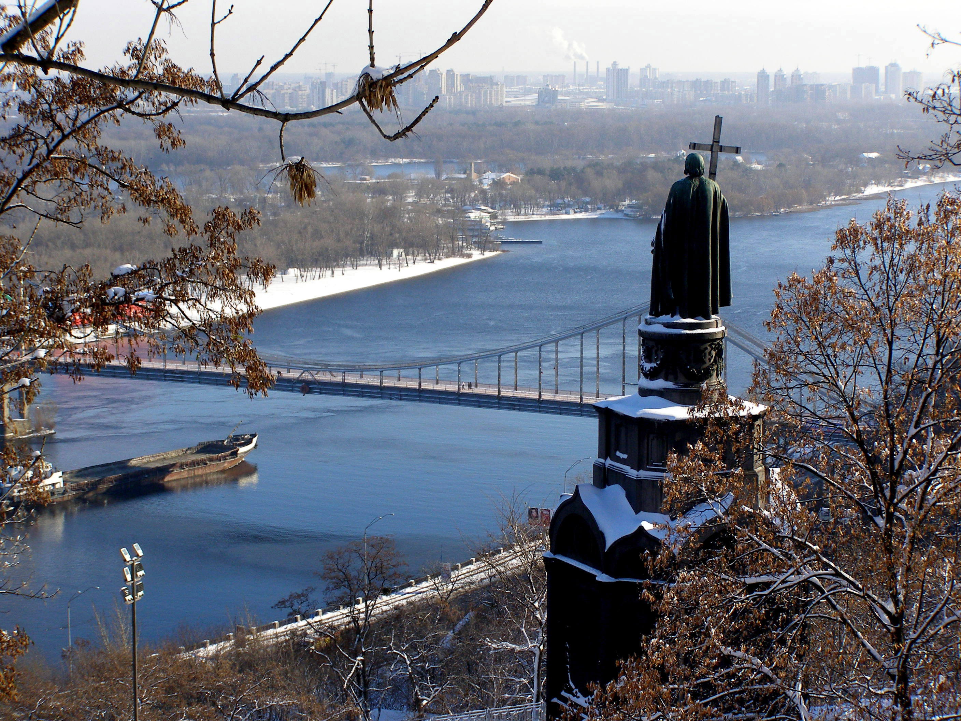
Fig. 1. Fragment of the Kyiv city

results and discussion

Formula
Formula should be typewritten (use, e.g., Microsoft Equation Editor). Subscripts and superscripts should be clear. Give the meaning of all symbols immediately after equation in which they are first used. Equations should be numbered sequentially at the right-hand side in parentheses. In general, only equations explicitly referred to in the text need to be numbered. Leave one blank lines before and after equations.

(1)

where c = focal length
x, y = image coordinates
X0, Y0, Z0 = coordinates of projection centerline Extended
X, Y, Z = object coordinates

conclusions

REFERENCES

References are placed on the end part of the article, and written alphabetically (10 pts) (style References). There should be active link with the reference list and citation in the text (for example, Gorbacova et al., 2016). Journal names should be given in full. Titles of papers should be given in their original language with if possible, they should be followed by a translation into English in parentheses. The examples on how to write references are provided below:

Journals

Khrystyuk B., Gorbachova L., Koshkina O. The impact of climatic conditions of the spring flood formation on hydrograph shape of the Desna River. Meteorology Hydrology and Water Management. 2017. Vol. 5(1). P. 63-70. http://dx.doi.org/10.26491/mhwm/67914
Gorbachova L.О., Khrystyuk B.F. The hydrologic regionalization of the territory of Ukraine for the formation conditions of the annual streamflow based of Andrews’ curves. Ukrainian Geographical Journal. 2016. № 3. P. 27-33. In Ukrainian. [Горбачова Л.О., Христюк Б.Ф. Гідрологічне районування території України за умовами формування річного стоку води на основі кривих Ендрюса. Український географічний журнал. 2016. № 3. С. 27-33.]

Proceedings (abstract) of conference

Pavla Pekárová, Pavol Miklánek, Ján Pekár, Liudmyla Gorbachova Analysis of changes in the hydrological regime of the Danube River at Reni. Proceedings of Peer-reviewed Contributions of the Tenth International Scientific Conference "Influence of Anthropogenic Activities on Water Regime of Lowland Territory". Zemplinska sirava, 22-24 May 2018, Michalovce, Slovak Republic. 2018. P. 205-217.
Gorbachova L. Spatio-temporal fluctuations of minimum flow in the Danube basin within Ukraine. Book of abstract of the XXVII Conference of the Danubian countries on Hydrological Forecasting and Hydrological Bases of Water Management. 26-28 September 2017, Golden Sands, Bulgaria. 2017. P. 26.

Books

McCuen Richard H. Modeling hydrological change: statistical methods. Lewis Publishers. 2003. 433 p.

